Step1: go to IAM-master-role

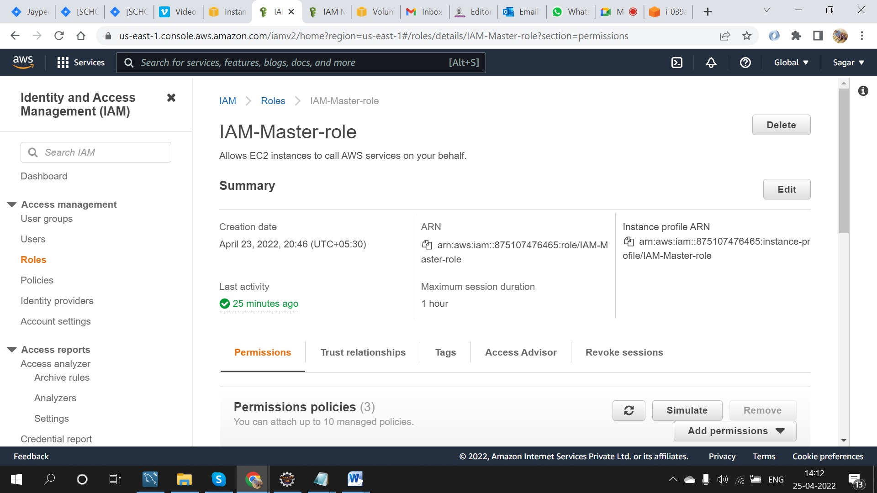

Step2: click on ADD permisiion and attach [AmazonEBSCSIDriverPolicy](https://us-east-1.console.aws.amazon.com/iam/home#/policies/arn:aws:iam::aws:policy/service-role/AmazonEBSCSIDriverPolicy)

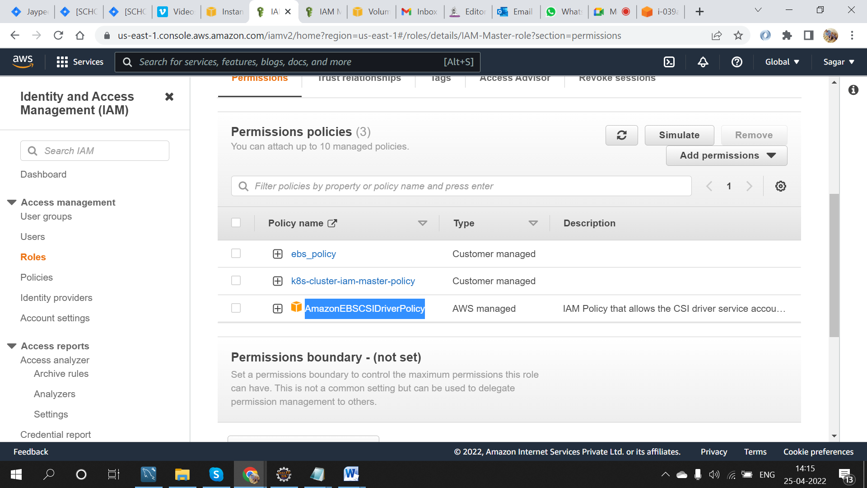

Step3: goto policies create a new policy by any name and choose service as ebs and select all action and choose All resources in resouces

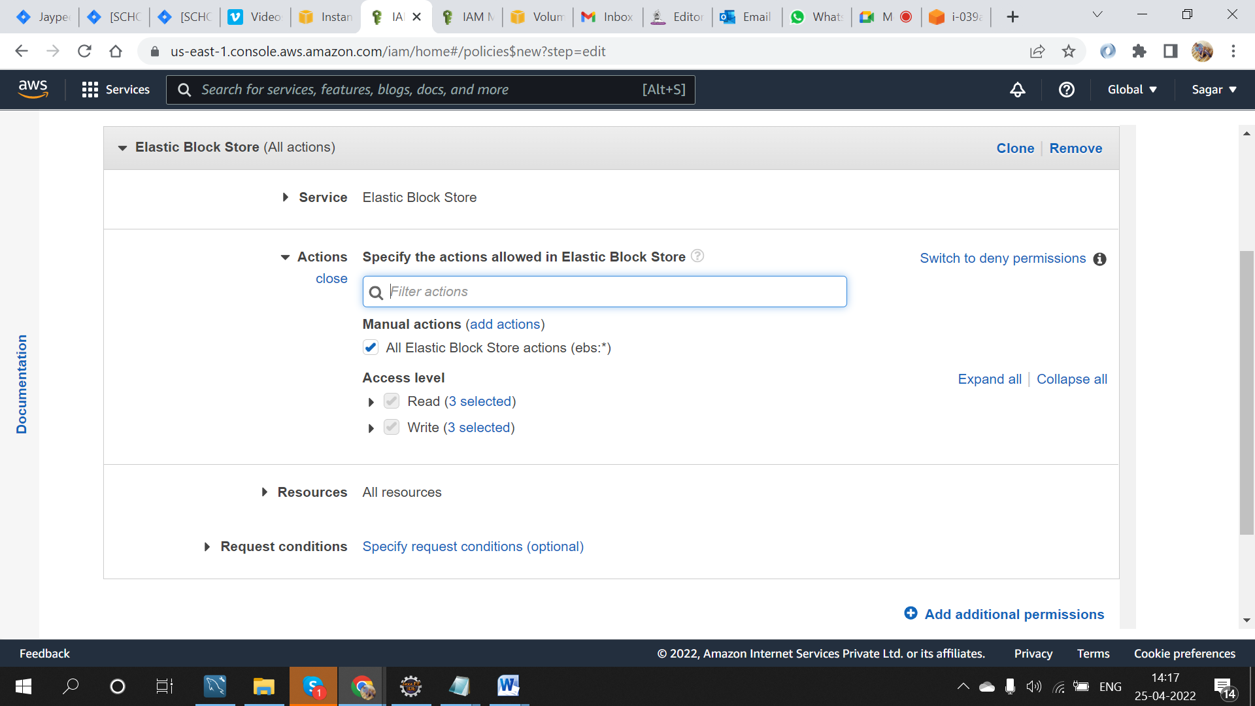

Step4: Goto IAM-master-role and attach the policy created .

Step5: follow the same steps in [IAM-Worker-role](https://us-east-1.console.aws.amazon.com/iamv2/home#/roles/details/IAM-Worker-role) from step1 to step4 and then reboot all the master and worker instances.

Step6:

curl https://raw.githubusercontent.com/kubernetes-sigs/aws-ebs-csi-driver/master/deploy/kubernetes/secret.yaml > secret.yaml

# Edit the secret with user credentials

kubectl apply -f secret.yaml

kubectl apply -k "github.com/kubernetes-sigs/aws-ebs-csi-driver/deploy/kubernetes/overlays/stable/?ref=release-1.5"

step7:

kubectl apply -f storageclass.yml

step8:

kubectl apply -f tomcat-pvc.yml

step9:

kubectl get pv

step10:

kubectl get pvc

